Hilary Valencia-Walsh
SWDV 691
DoggoFindr

Proposed Project Idea and Minimum Viable Product

Proposed Project Idea:
DoggoFindr is a responsive web application that finds dogs homes. Yes, there are many dog adoption sites. Why another one like DoggoFindr? DoggoFindr not only allows for adoptions but also allows for fostering. The user will be able to go through a list of dogs, view information and pictures of the dog, and if they choose so, will go through an application to apply for the chosen dog. DoggoFindr will then message the breeder/rescue/foster family with the application information, and they can choose which applicant best suits the dog and then discuss adoption. DoggoFindr has a Foster feature that allows users to find out more information about fostering, and how to get started with fostering. If the user chooses to get started with fostering, they will fill out an application to make sure they are a good candidate to do so. Doggofindr also has merchandise with all proceeds going to foster families to take care of the dogs they are fostering.

Minimum Viable Product:

Navbar | Buttons + Links
Login/Signup | Takes you to signup/login page
Find a friend | Takes you to homepage
Adoption Application | Adoption application
Foster | About Fostering, Foster Parent Application
Shop Merchandise | To store
Contact Us | Contact us page

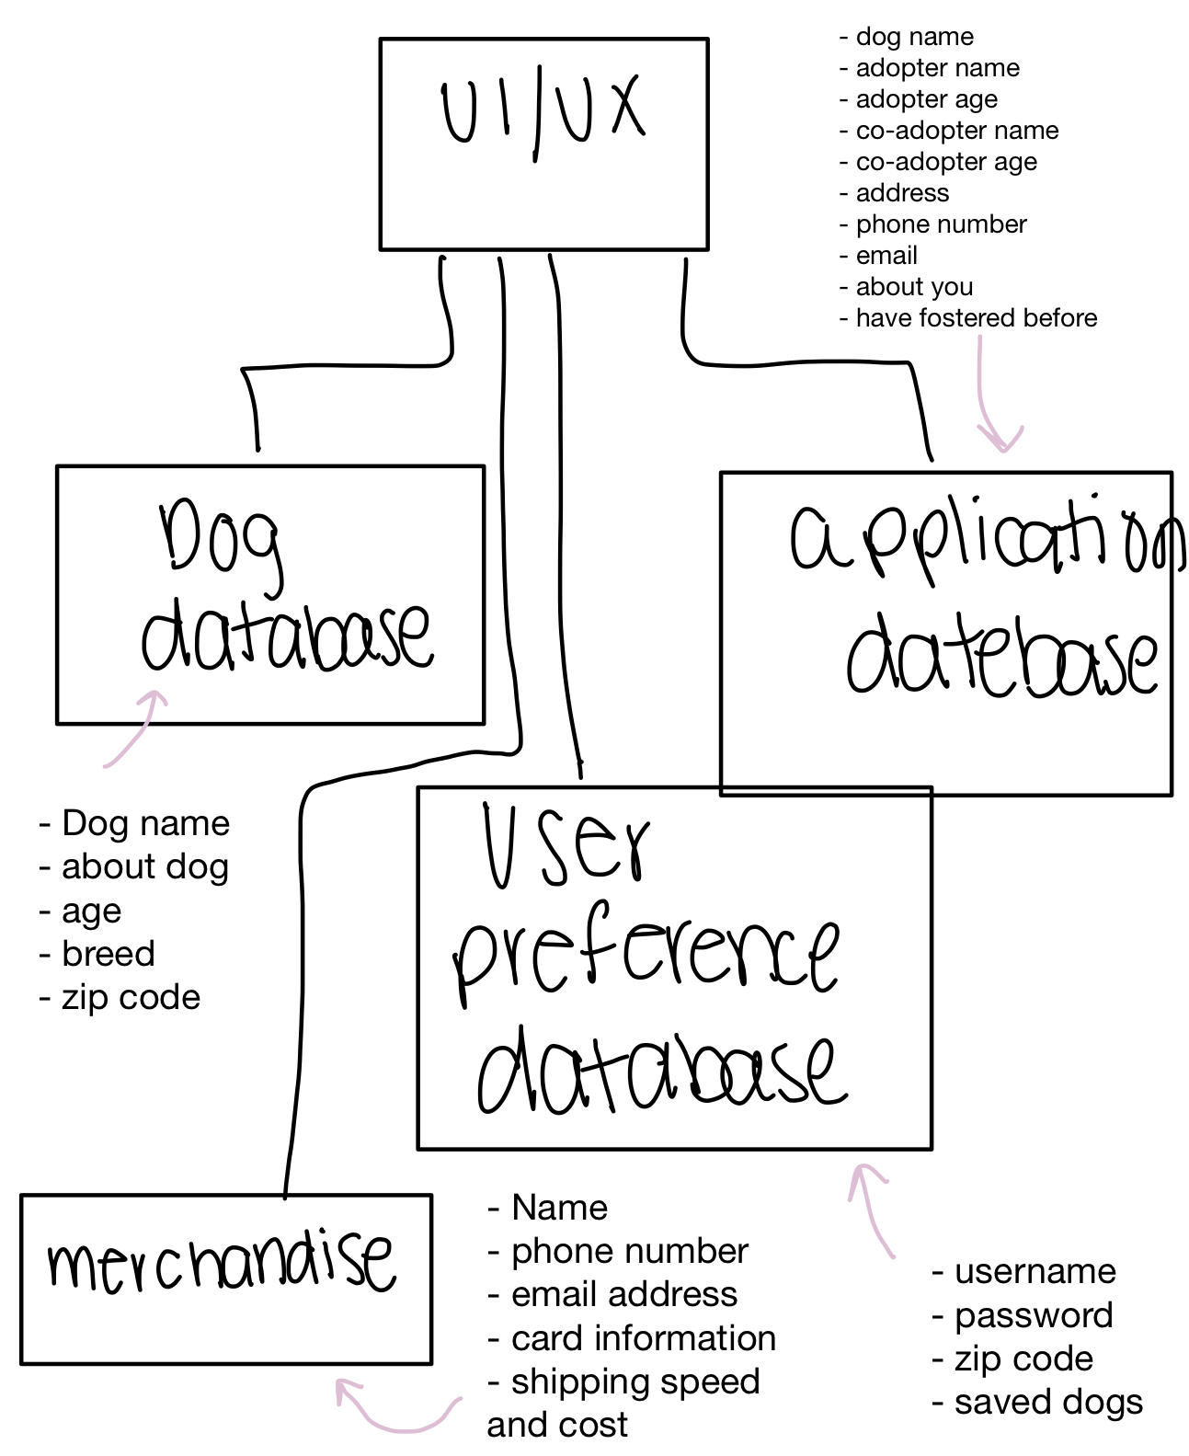

User profiles:
Pet Lover Randy
Background: Has a farm, has adult children who help him take care of their animals on the farm, Randy is also older, and retired used to be a vet.
Demographics: 55 years old, lives in Enumclaw, WA (farm town), makes 100,000 a year from retirement
Identifiers: Loves animals, wants to help animals in need, has their own rescue property
Shopping Sally
Background: Lives in a city area, works from home and has children, younger, loves to shop and give back to the community
Demographics: 30 years old, lives in Bellevue, WA (city), makes 150,000 a year
Identifiers:
Loves animals, gives back to the community by shopping for merch, or donating on websites
Young Eloise
Background: Lives in a smaller town, has no children, just her and husband, has always had pets
Demographics: 24 years old, lives in Mercer Island, WA, combined they make 90,000 a year Identifiers: loves animals, looking for a pet of their own as they just moved into their first place
